DAY, NIGHT AND SEASONS

Day and Night
The Earth spins once every 23 hours 56 minutes 4.2 seconds (roughly 24 hours) in a west-east direction.
i.e. The Sun rises in the east and sets in the west.

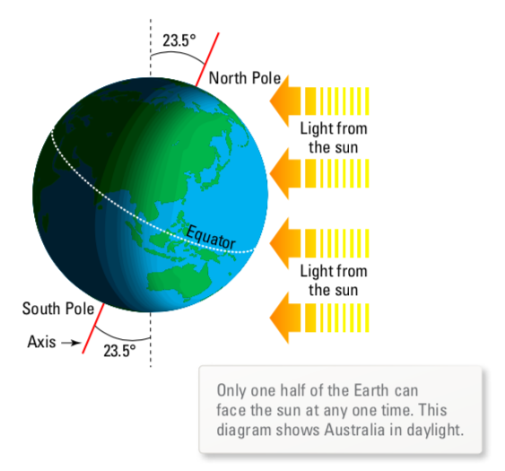

In our summer, the closer you travel to the South Pole, the longer the hours of sunlight
(24 hours at the pole!)

Minutes and seconds were derived as divisions of the day.
i.e. 1 hour = 1/24 of a day
1 second = 1/86,400 of a solar day.

Year
The Earth takes 365.25 days to complete one revolution of the Sun.

Julian calendar - organised in 46 BC with 365 days in a year and a leap year every four years.

Gregorian calendar - developed about 1600 AD. By this time the calendar was at least 10 days out from the Earth’s movement about the Sun so they were cancelled. Also, a leap year that was divisible by 400 would not have a leap day added.
e.g. 1600 and 2000 are not leap years.
There are several terms associated with the solar year.

Summer solstice - longest day (December 21 in Australia)

Winter solstice - shortest day (June 21)

Spring equinox - length of night and day are equal (March 21)

Autumn equinox - length of night and day are equal (September 21)

Seasons

The seasons occur on Earth because it is “tilted” at 23.5° to the plane of its orbit around the Sun.
